# Automatic Profile Selection and Summary

## Quick run steps

**Unpack the application:**

First unzip or clone the repository and change (or move) to root directory of the application.

Root directory is where you see below folders.

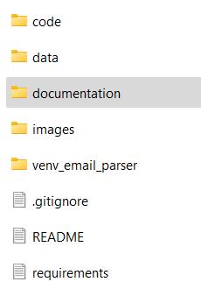

**Setup the virtual environment:**

**After moving to the application root directory, open the command prompt (in case of windows), then create a virtual environment using the below command**

**virtualenv myenv**

**Activate the virtual environment**

**Myenv\Scripts\activate**

**Install the required packages using the following command**

**pip install -r requirements.txt**

**Running the application:**

To start the application open command prompt in the root directory (or change to root directory, in case of linux) then run the below command.

streamlit run code/Home.py

## Application usage

On running the application, copy the url from the command prompt, it should be like something below

On lunching the url in the browser it should show the home page like below.

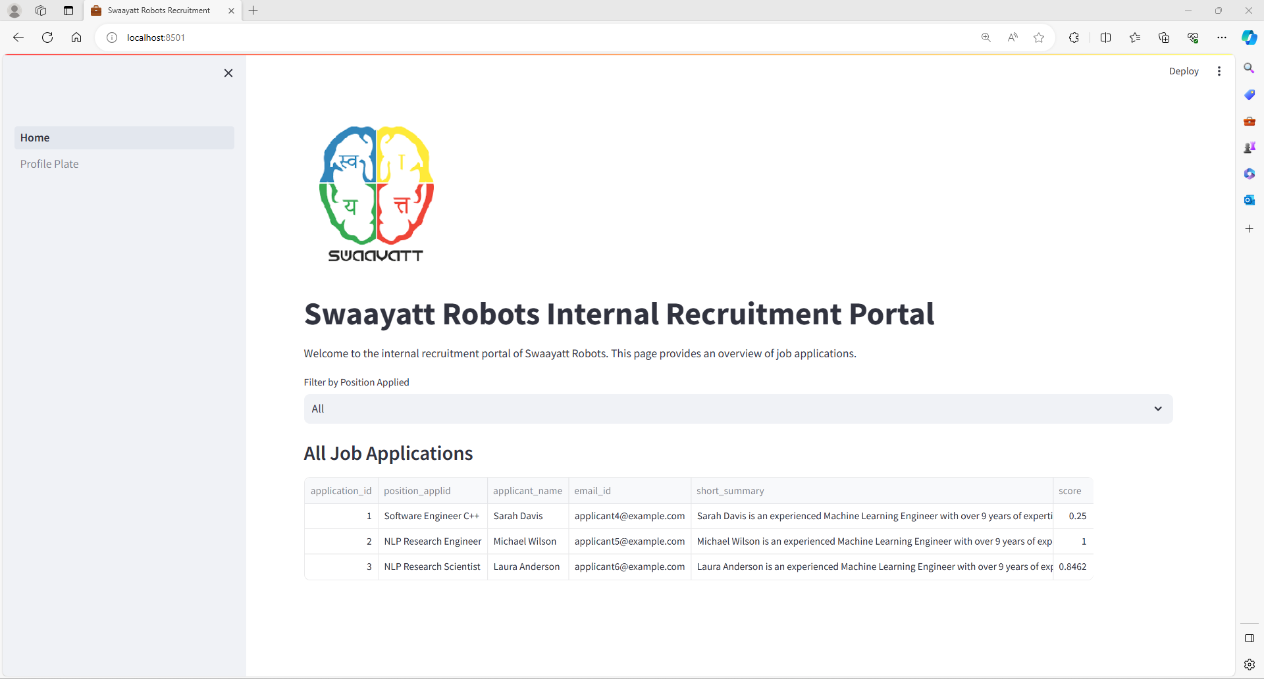

Home page gives overview of the applications received for different positions.

Profile Plate is another page where you can see the complete details of the of the individual selected profile.

## Pages explanation

**Home page:**

**Table on the home page shows all the applications received to the different positions. This table contains the necessary information including but not limited to candidate name, position applied, short summary of the candidate based on the resume attached, score indicating how strong the candidate matches the job requirements based on the preset rubrics.**

**Dropdown is provided to filter the applications based on the position.**

**Click on any header to sort the table accordingly.**

**Double click on the short summary would expand show full content of the cell.**

**Profile Plate:**

**This page is to deep dive into further details of the application/candidate profile.**

**Select one application id from the provided dropdown.**

**Candidate score indicates how good fit the candidate is to the given job requirement. This is a score between 0 and 1, 1 being maximum and 0 is minimum.**

**Education, Projects, Work Experience sections are the model generated summaries from the provider resume of the candidate.**

# **Mean shift filter**

There are two scripts (solutions ) in the folder.

1. Using the opencv existing method, that is in the file mean_shift_filter.py
2. From scratch implementation, that is in the mean_shift_filter_algorithm.py

input test image for the scripts are in the home directory: mandril_color256.jpg, image looks below

Opencv method results:

Used spatial bandwidth as 10, range bandwidth as 20

From scratch implementation results:

Used spatial bandwidth as 10, range bandwidth as 20

